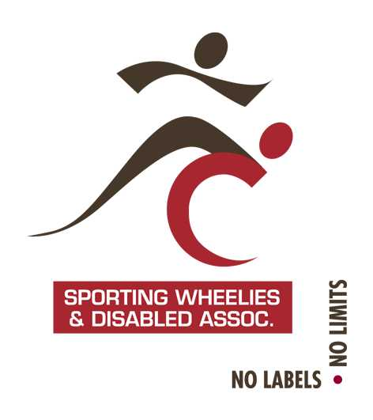
Memo
TO: Paralympic seven-a-side football players and volunteers
CC: Football Queensland staff
FROM: Robyn Stephensen (Sport Development Coordinator)
RE: 2016 Paralympic 7-a-side Football National Championships

Hi All
Sporting Wheelies and Disabled Association are calling for nominations to the Queensland team to contest the 2016 Paralympic 7-a-side Football National Championships. Please see below information relating to this event.
All players must be an active member of either an FQ club or a recognised inclusive football program, as well as a current financial member of Sporting Wheelies and Disabled Association.
If you wish to nominate for the Queensland team for this event, please complete the attached forms and submit, along with your nomination fee of $100 per person no later than Friday 2 September 2016.
Please note that no late nominations will be accepted. If we do not receive enough nominations then a Queensland team will not contest the event.

Dates and Venue
This year’s championships will be held at the Football NSW grounds, Valentine Sports Park in Glenwood (Sydney) NSW. The tournament will run from 27-30 October 2016.

Travel
The Queensland team will travel to Sydney on Wednesday 26 October 2016, returning in the evening Sunday 30 October 2016.
Our Association will make travel arrangements on behalf of all Queensland team members. It should also be noted, that this year flight costs for ALL teams will be equalised across all teams.

Accommodation
Accommodation will be provided on-site at Valentine Sports Park. Rooms will be either quad or twin share.

Meals
Meals will also be provided on-site at Valentine Sports Park including breakfast, lunch and dinner.

Classification
Please note that only players who are classified or able to meet Paralympic Football classification criteria will be eligible to play at the national championships. For more information on classification, please visit our website http://www.sportingwheelies.org.au/our-services/sport/classification/

Team Staff
Anyone wishing to apply for a Team Staff position must complete the attached Team Staff nomination form and return no later than Friday 2 September 2016.

Supporters
If you have any family/friends wishing to travel with you and requiring flights, accommodation, transport, meals etc; they must also complete a nomination form. If your supporters do not require us to book anything on their behalf, we do not require a nomination form from them.

Uniforms
Football Queensland will be providing a playing kit for all team members.

Costs
We estimate the full cost per athlete including flight equalisation, accommodation, meals and staff costs to be $700. This amount is approximate only and is before association subsidy if you are eligible. You will be invoiced for your final costs, which must be paid in full prior to the event.

National Level Subsidy
Players will be entitled to apply for a national-level subsidy for this event through Sporting Wheelies and Disabled Association’s Athlete Funding program. Approved members will receive a 50% subsidy on approved event costs. Please note that only players who nominated for the Festival of Football will be entitled to apply for a funding subsidy.

Selection
All nominations (players and team staff) will be considered by the Selection Committee in order to select the final Queensland team to contest the championships. Any players who are not selected in the final team will have their nomination fee refunded.

Nomination Process
To nominate for the Queensland team for this event, please ensure the following are completed. Your nomination will not be considered received until ALL forms and nomination payments have been received.

- Complete the relevant Nomination Form
  - Player
  - Team Staff
  - Supporter

- Complete Application for Funding Form (available on the association website)

- Complete the Medical Information Form

- Pay initial nomination fee of $100 per person

- Return all of the above to:

Sporting Wheelies and Disabled Association
Email: mailbox@sportingwheelies.org.au
Post: 60 Edmondstone Road, Bowen Hills Qld 4006
Fax: (07) 3253 3333
Closing Date: Friday 2 September 2016

